Clickstream IQ
Intelligent E-Commerce Analytics Platform



Data Exploration
Dataset Profiling, Behavioral Analysis & Anomaly Injection Preparation
Project: Ecommerce Clickstream Anomaly Engineering
Dataset: 2019-Oct.csv
Analysis period: October 1–31, 2019
Environment: Windows, VS Code, Jupyter Notebook, Python, Polars
Current phase: Data Exploration and Anomaly Scenario Design
Status: Exploration completed for the documented checks; anomaly injection has not started.

1. Executive Summary
The objective of this phase was to explore the original ecommerce clickstream dataset, understand its structure and behavioral patterns, measure data quality, and establish a baseline before designing synthetic anomalies.
The dataset contains approximately 42.45 million event records describing ecommerce user activity, including product views, cart additions, and purchases.
The exploration covered:
- Dataset size and schema.
- Event-type distribution.
- Missing values.
- Time coverage.
- Exact duplicate records.
- Daily activity patterns.
- User-session statistics.
- Repeated product views in unusually large sessions.
- Chronological event-sequence inspection.
- Preparation of anomaly scenarios for a future data-engineering pipeline.

The analysis was performed using Polars to work with a large CSV efficiently. The original dataset was treated as read-only.
Key findings
Metric | Observed result
Total records | 42,448,764
Number of columns | 9
File size | Approximately 5.28 GB
Event types | 3
User sessions, excluding null session IDs | 9,244,421
Exact duplicate groups | 18,099
Extra rows belonging to exact duplicate groups | 30,220
Missing category_code values | 13,515,609
Missing brand values | 6,113,008
Missing user_session values | 2
Sampled event records inspected for sequences | 75
Purchases without a prior matching view in the inspected sample | 0
These results describe the original dataset. They do not represent the number of synthetic anomalies injected into it.

2. Project Objective and Scope
The exploration phase was designed to answer five main questions.
- What does the original dataset contain?
- What is the normal distribution of ecommerce events?
- What data-quality issues already exist in the source?
- What user behaviors and event sequences can be observed?
- How can synthetic anomaly scenarios be designed without confusing existing data characteristics with injected anomalies?
The exploration was also intended to prepare the dataset for later processing and analytics.
Scope limitations
At this stage:
- No synthetic anomalies have been injected.
- No existing records have been deleted.
- No source columns have been added, removed, renamed, or recast.
- No original missing values have been imputed.
- Existing exact duplicates have not been removed.
- No anomaly labels have been added to the source.
- No machine-learning model has been trained.
- No final anomaly injection rates have been approved.
The current results are exploratory findings, not a final anomaly-detection model or a cleaned production dataset.

3. Dataset Overview
3.1 Source file
The dataset used for the exploration is:

2019-Oct.csv
The file was placed in the following working directory:
The dataset file size was approximately 5.28 GB.
The dataset contains ecommerce interaction events collected during October 2019.
Each row represents an event, such as viewing a product, adding a product to a cart, or purchasing a product.
3.2 Dataset columns
The original dataset contains nine columns.
Column | Original data type | Description
event_time | String | Timestamp of the recorded event
event_type | String | Type of ecommerce event
product_id | Int64 | Identifier of the product
category_id | Int64 | Identifier of the product category
category_code | String | Product category classification
brand | String | Product brand
price | Float64 | Product price recorded for the event
user_id | Int64 | Identifier of the user
user_session | String | Identifier of the user session
Important schema decision
The event_time column was kept as a string during this phase.
Although timestamps are commonly converted to a datetime data type for temporal analysis, no such conversion was performed in the source DataFrame because the agreed scope was read-only exploration without schema changes.

The timestamp strings follow a format similar to:
2019-10-01 06:43:04 UTC
This format allowed chronological sorting for the inspected records because the timestamps use a consistent layout and UTC timezone notation.

4. Development Environment and Tools
The exploration was conducted locally on Windows using VS Code and Jupyter Notebook.
4.1 Python environment
A dedicated virtual environment was created in the project directory:
D:\Samsung\Graduation Project\Data\Old Data\.venv
The Python interpreter selected for the notebook was:
D:\Samsung\Graduation Project\Data\Old Data\.venv\Scripts\python.exe
The environment was tested successfully.
4.2 Libraries
Tool or library | Purpose
Python | Analysis programming language
Polars | Large-scale tabular and lazy data processing
Jupyter Notebook | Interactive exploration
VS Code | Development environment
ipykernel | Notebook kernel integration
The installed Polars version was 2.0.0.
4.3 Why Polars was selected
The CSV contains more than 42 million rows and occupies several gigabytes.
Loading the entire dataset into a conventional in-memory DataFrame can require substantial RAM. Polars Lazy API was therefore used to build queries that could be optimized and executed when needed.
The analysis used scan_csv() rather than eagerly loading the entire CSV into memory.

5. Loading the Dataset
The source file was referenced using the notebook's current working directory.
The initial loading code was:
from pathlib import Path
import polars as pl

DATA_PATH = Path.cwd() / "2019-Oct.csv"

df = pl.scan_csv(
DATA_PATH,
infer_schema_length=10_000,
null_values=["", "null", "NULL"]
)
Explanation
- Path.cwd() retrieves the notebook's current working directory.
- DATA_PATH points to the original CSV.
- pl.scan_csv() creates a lazy query rather than immediately loading all records into memory.
- infer_schema_length=10_000 uses the first 10,000 records to infer column types.
- null_values instructs the CSV reader to interpret empty strings and the specified literal values as nulls.

Important: The null_values argument affects how the file is interpreted during analysis. It does not rewrite the original CSV or fill missing values.
The schema observed during exploration contained the nine original columns listed in Section 3.

6. Dataset Size and Record Count
The total record count obtained during exploration was:
42,448,764 rows
The dataset contained nine columns.
This makes it a large clickstream dataset suitable for exploring scalable data processing, session analytics, data quality, and anomaly-injection scenarios.
The file itself was approximately 5.28 GB.
These measurements established the baseline dataset size before any future synthetic modifications.

7. Event-Type Distribution
The original dataset contained three event types:
- view
- cart
- purchase
No remove_from_cart event type was observed.
7.1 Observed event counts
Event type | Count | Percentage
view | 40,779,399 | 96.07%
cart | 926,516 | 2.18%
purchase | 742,849 | 1.75%
Total | 42,448,764 | 100%
Percentages are rounded to two decimal places.
7.2 Interpretation
Product views
Views represent approximately 96.07% of all records. This is expected in a clickstream dataset because users can view products without subsequently adding them to their carts or purchasing them.
Cart additions
Cart events represent approximately 2.18% of all records.
A cart event indicates that a product was added to the user's cart, but it does not guarantee a later purchase.
Purchases
Purchase events represent approximately 1.75% of all records.
This is an event-level proportion, not a unique-user conversion rate. A user may generate multiple events or purchase multiple products.
Important modeling consideration
The three event types are not necessarily mutually exclusive at the user or session level. The same user session may contain views, cart additions, and purchases.
The distribution provides an important baseline for later anomaly generation, especially when designing synthetic purchase surges or bot-like browsing behavior.

8. Missing-Value Analysis
The original data was profiled for null values across the nine columns.
8.1 Observed missing-value counts
Column | Missing values
event_time | 0
event_type | 0
product_id | 0
category_id | 0
category_code | 13,515,609
brand | 6,113,008
price | 0
user_id | 0
user_session | 2
8.2 Interpretation
category_code
A total of 13,515,609 records had missing category_code values.
This is a substantial amount of missing category information. However, a missing category code does not automatically indicate an anomalous event. It may reflect incomplete product metadata or the source dataset's original structure.
brand
A total of 6,113,008 records had missing brand values.
Similarly, these records should not automatically be classified as anomalies. A product may not have a brand value recorded in the source.
user_session
Only two records had missing session identifiers.
This is a small count compared with the total dataset size, but those records cannot be assigned reliably to a session without additional information.
Other columns
No null values were observed in event_time, event_type, product_id, category_id, or price.
8.3 Data-quality decision
The missing values were preserved.
No imputation or replacement was performed, and missing category_code or brand values were not treated as synthetic anomalies.
This distinction is important because the project must separate naturally occurring source-data characteristics from anomalies deliberately introduced later.

9. Time Coverage Analysis
The earliest and latest timestamps observed were:
Metric | Value
Earliest timestamp | 2019-10-01 00:00:00 UTC
Latest timestamp | 2019-10-31 23:59:59 UTC
Coverage | October 1–31, 2019
The dataset covers the entire month of October 2019.
Interpretation
This time coverage allows analysis of:
- Daily event volume.
- Daily purchase counts.
- Daily cart additions.
- Temporal changes in user activity.
- Synthetic promotional periods.
- Changes in session behavior over time.
However, a single month of data does not provide enough historical context to confirm recurring seasonal behavior across multiple years.
Any promotional surge introduced later must therefore be explicitly documented as synthetic rather than presented as a verified historical campaign.
The original event_time column remained a string throughout the exploration.

10. Exact Duplicate Analysis
The dataset was checked for records that were identical across all nine original columns.
The observed results were:
Metric | Result
Exact duplicate groups | 18,099
Extra rows belonging to duplicate groups | 30,220
10.1 What is an exact duplicate?
Two records are exact duplicates under this check when all nine columns match:
- event_time
- event_type
- product_id
- category_id
- category_code
- brand
- price
- user_id
- user_session
10.2 Difference between duplicate groups and extra rows
A duplicate group represents a set of identical records.
The extra duplicate-row count represents the additional copies beyond one retained representative of each group.
For example, if the same complete record appears three times, it contributes one duplicate group and two extra rows.
Therefore, the two metrics measure different things.
10.3 Important interpretation
The existence of exact duplicates does not prove that all of them are errors.

A repeated event could be caused by source-system behavior, ingestion retries, or repeated activity that happens to have identical recorded fields.
The exploration did not establish the origin of these duplicates.
Decision
- Existing exact duplicates were not deleted.
- The source file was not deduplicated.
- Existing duplicates were not automatically labeled as injected anomalies.
The future synthetic duplicate scenario must be distinguishable conceptually from the exact duplicates already present in the original data.
For the strictest exact-record comparison, all nine columns are the relevant fields. A composite key made from only two columns could incorrectly flag legitimate events as duplicates.

11. Daily Event Distribution
Daily event counts were examined to understand how activity varied during October 2019.
Some of the observed daily counts were:
Date | Cart events | View events | Purchase events
October 1 | 16,658 | 1,208,280 | 19,307
October 4 | 43,829 | 1,346,320 | 27,041
October 13 | 24,833 | 1,584,677 | 29,561
October 14 | 44,858 | 1,381,439 | 28,405
October 16 | 45,279 | 1,445,717 | 31,394
October 17 | 40,378 | 1,338,311 | 28,318
These are selected observations, not the complete daily summary table.

11.1 Observations
- October 16 had the highest purchase count among the dates examined, at 31,394 purchases.
- October 13 had 1,584,677 views among the listed dates.
- Cart counts varied substantially between the listed days.
- October 1 had lower observed cart and purchase counts than several of the later dates shown.
11.2 Interpretation and limitations
Daily activity varies in the original dataset. That variation is important when defining a future synthetic purchase surge.
A surge should not simply be defined as a day with more purchases than another day. The rule should account for the baseline distribution and should be explicitly documented.
The existing observations do not establish that a real promotion occurred on any of these dates.
A future synthetic promotional period should therefore be clearly identified as a designed scenario, not as a factual claim about an actual marketing campaign.

12. User-Session Analysis
The exploration examined how events were distributed across user sessions.
A session groups related events using user_session.
12.1 Session count
The number of sessions with non-null session identifiers was:
9,244,421 sessions
The two records with missing user_session values were excluded from this session count.
12.2 Distribution of events per session
The observed session-size statistics were:
Statistic | Events per session
Minimum | 1
Median | 2
90th percentile | 10
95th percentile | 16
99th percentile | 32
Maximum | 1,159
12.3 Interpretation
Most sessions were small.
The median session contained two events. Ninety percent of sessions contained ten events or fewer, and 99% contained 32 events or fewer.
However, at least one session contained 1,159 events, substantially more than the observed median.
This makes session size a useful feature to investigate when designing bot-like crawling scenarios.
Important limitation
A large session is not automatically a bot.
A genuine user may browse many products, and the source data alone does not establish whether an unusually large session was generated by a human or automated software.
Session size should therefore be combined with other behavioral indicators rather than used as the only anomaly rule.

13. Repeated Product Views in Large Sessions
The exploration examined some of the largest sessions and compared total view events with the number of distinct products viewed.
The calculation used the following concept:
repeated_view_events = view_events - distinct_products
Selected observed results were:
Session sample | View events | Distinct products | Repeated-view count
Session 1 | 1,158 | 290 | 868
Session 2 | 564 | 88 | 476
Session 3 | 584 | 218 | 366
Session 4 | 1,137 | 868 | 269
Session 5 | 325 | 64 | 261
These are selected large sessions from the exploration, not representative averages for all sessions.
13.1 Interpretation
The first session had 1,158 view events involving 290 distinct products. The difference was 868.
This indicates that the number of view events substantially exceeded the number of distinct products in that session.
The other listed sessions also contained repeated product views.
13.2 Important limitation
The calculation above is a simple difference between total views and distinct products. It does not measure consecutive repetitions, time between repeated views, or the number of repeated events for every individual product.
It is therefore an exploratory indicator rather than a definitive bot-detection metric.
For stronger bot-like crawling detection, later analysis can examine:
- Total events within a session.
- Views per unit of time.
- Number of distinct products.
- Repeated views of the same product.
- Time intervals between events.
- Session duration.
- The proportion of events that are views.
These features should be evaluated together to reduce false positives.

14. Event Sequence Inspection
The next stage examined the chronological order of events within a small sample of user sessions.
The purpose was to understand the existing event patterns before defining synthetic impossible-sequence anomalies.
14.1 Sample selection
Five sessions containing at least two distinct event types were selected.
The resulting sample contained:
75 event records across five sessions
The records were displayed in chronological order using event_time.
The inspection selected only these columns:
- user_session
- event_time
- event_type
- product_id
No source columns were added or removed.
14.2 Observed examples
Example 1: View followed by purchase
For product 1005098, the observed events were:
Time | Event
2019-10-01 06:43:04 UTC | view
2019-10-01 06:44:53 UTC | purchase
This is consistent with a product being viewed before it was purchased.
Example 2: View and purchase with a later view
For product 4804409, the observed events were:
Time | Event
2019-10-01 07:26:45 UTC | view
2019-10-01 07:28:48 UTC | purchase
2019-10-01 07:29:14 UTC | view
This sequence contains a view before the purchase and another view afterward.
A later view does not automatically make the sequence impossible. The user could revisit a product after purchasing it.
Example 3: Repeated views before purchase
The sample also contained a session with multiple views of product 1802019 before and after a purchase.
This illustrates why a sequence rule must evaluate event ordering and product identity rather than merely count how many events occur.
14.3 What the sample establishes
The sampled records demonstrate that ordinary sequences can include:
- View followed by purchase.
- Multiple views before purchase.
- A view after purchase.
- Events involving different products within the same session.
The sample is too small to characterize every possible sequence in the full dataset.

15. Purchase Without a Prior Matching View
A specific check was then implemented to identify purchase events that had no earlier view event for the same product within the same user session.
The matching criteria were:
- The same user_session.
- The same product_id.
- A view event with an earlier event_time than the purchase.
The check was applied to the five sampled sessions.
15.1 Observed result
The output was:
shape: (0, 4)
The result contained zero rows.
Therefore, no purchase in the inspected sample lacked an earlier matching view for the same product in the same session.
15.2 Interpretation
This result means that the five sampled sessions did not contain a case meeting the specified rule.
It does not establish that the entire dataset contains no such cases because the check was performed only on the sample.
It also does not prove that a purchase without a recorded prior view is necessarily invalid. The user might have viewed the product before the session began, or an event might not have been captured.
Decision for future anomaly design
The scenario remains a candidate for synthetic impossible-sequence injection, but its rule must be defined precisely.
A possible rule is to generate a purchase for a product within a session without any earlier view of that product in that session.
This would be a deliberately constructed sequence anomaly. It should not be confused with proof that all similar patterns in real source data are errors.

16. Selected Anomaly Scenarios
Five scenarios were selected for future investigation and design.
The scenarios are labeled A, B, C, D, and F. No scenario E was selected.
A. Cart Abandonment
Objective: Represent sessions in which a product is added to the cart but is not purchased later.
Potential rule:
- Identify a cart event for a particular product.
- Examine later events for the same product in the same session.
- Identify cases without a subsequent purchase during the defined observation window.
Business relevance:
Cart abandonment is useful for understanding the difference between product interest and completed purchases.
Important distinction:
Cart abandonment is a common ecommerce behavior, not necessarily a data-quality error or fraudulent event.
It should be treated as a behavioral scenario rather than automatically classified as a confirmed anomaly.
The current dataset has no observed remove_from_cart event type, so the scenario must not depend on that event.
B. Bot-like Crawling Loops
Objective: Represent automated or unusually repetitive product browsing.
Potential indicators:
- Unusually high event counts per session.
- Many view events within a short period.
- Repeated views of the same product.
- High view-to-other-event ratios.
- Very short intervals between consecutive events.
Exploration evidence:
The session analysis found a maximum of 1,159 events in one session and repeated-view counts of 868 in one of the selected large sessions.
These observations provide candidates for further analysis, but they do not establish that those sessions were generated by bots.
Future requirement:
Define thresholds using the original data's observed distribution, then generate synthetic cases that clearly satisfy the chosen rules.
C. Seasonal Promotional Purchase Surges
Objective: Represent an artificial increase in purchase activity during a defined promotional window.
Potential behavior:
- A sharp increase in purchase-event volume.
- A higher purchase count than the baseline for comparable periods.
- Potentially different relationships between views, cart additions, and purchases.
Exploration evidence:
Purchase counts varied by date. October 16 had 31,394 purchases among the dates examined.
Important limitation:
The dataset covers one month of one year. It does not by itself establish recurring seasonality or verify the existence of an actual promotion.
The future surge should be documented as a synthetic campaign scenario.
D. Duplicate Events
Objective: Represent duplicate records deliberately introduced into a future dataset.
Exploration evidence:
The original data already contained:
- 18,099 exact duplicate groups.
- 30,220 extra duplicate rows.
Important distinction:
The existing duplicate records are part of the original baseline and have not been removed.
A future injection process must distinguish deliberately added duplicate copies from duplicates already present in the source.
A strict exact-record comparison should consider all nine original columns. A two-column key alone may flag legitimate records as duplicates.
F. Impossible Sequences
Objective: Represent event sequences that violate a defined behavioral rule.
Candidate rule:
A purchase occurs without an earlier view of the same product in the same session.
Exploration evidence:
The five-session sample contained 75 records, and the specific check returned zero matching cases.
Important limitation:
The zero result applies only to the inspected sample. It is not a full-dataset result.
The scenario remains suitable for controlled synthetic injection if the rule is clearly documented and its limitations are understood.

17. Baseline Findings and Their Meaning
The exploration established several different types of baseline information.
Finding | What it tells us | What it does not prove
Views account for 96.07% of events | Views dominate event volume | That every high-view session is a bot
13.5 million missing category codes | Product category metadata is frequently missing | That these records are anomalies
18,099 exact duplicate groups | Identical records already exist in the source | That all duplicates are invalid
Maximum session size of 1,159 | Some sessions contain many events | That the largest session is automated
Repeated product views in large sessions | Some sessions revisit products frequently | That repeated views are necessarily abnormal
Zero qualifying purchases in the sample | No matching case was found in the inspected sessions | That the entire dataset has no impossible sequences
Daily purchase counts vary | Event volume changes over time | That a real promotion caused the changes
These distinctions are important for reliable anomaly engineering. The source's natural behavior must be understood before synthetic anomalies are introduced.

18. Target Anomaly Percentage
The planned anomaly proportion is 2% of the original dataset.
The original row count is:
42,448,764
Two percent of this number is:
42,448,764 × 0.02 = 848,975.28
This corresponds to approximately 848,975 rows.
However, the exact injection count depends on the final definition of the 2% target.
Two possible definitions must be distinguished:
Definition 1: Added rows equal 2% of the original dataset
The number of newly added rows would be approximately 848,975.
If all added rows were additional records, the final dataset would contain approximately 43.30 million rows.
Definition 2: Anomalous rows equal 2% of the final dataset
If the final dataset must have an anomalous-row proportion of exactly 2%, the required number of injected rows depends on how the final row count is calculated.
These definitions are not interchangeable.
The final denominator, anomaly definition, and injection counts should be fixed before generating the augmented dataset.
No anomaly rows have been injected yet.

19. Data Integrity and Schema Protection
The following constraints were maintained throughout the documented exploration.
- The original 2019-Oct.csv file was not overwritten.
- No original records were deleted.
- Existing duplicates were retained.
- Missing values were not filled.
- The nine original columns were preserved.
- event_time remained a string.
- No anomaly_type column was added.
- No is_injected_anomaly column was added.
- The proposed marketing_channel and platform columns have not yet been added.
- No final synthetic dataset has been produced.
Any future enriched or augmented output should be written to a separate file so that the original source remains available for comparison and reproducibility.

20. Outstanding Decisions Before Injection
The exploration has provided a starting baseline, but several decisions remain open.
20.1 Definition of the 2% target
Determine whether the 2% refers to:
- The number of rows added relative to the original dataset, or
- The percentage of anomalous rows in the final dataset.
20.2 Allocation across scenarios
Determine how the total anomaly budget will be distributed among:
- Cart Abandonment.
- Bot-like Crawling Loops.
- Promotional Purchase Surges.
- Duplicate Events.
- Impossible Sequences.
No per-scenario rates have been finalized.
20.3 Rules and thresholds
The exact rules for identifying and generating each scenario must be defined before injection.
For example, a bot-like session rule should use measured behavioral indicators rather than an arbitrary session-size threshold.
20.4 Synthetic metadata
The proposed marketing_channel and platform fields need definitions, permitted values, and a documented assignment strategy.
They have not been added to the dataset at this stage.
20.5 Output strategy
The output format and storage location for the future augmented dataset must be determined while preserving the original file.
20.6 Validation
After injection, the project should verify:
- Final row count.
- Number of rows added.
- Distribution of injected scenarios.
- Duplicate behavior.
- Event-type distribution.
- Timestamp coverage.
- Schema of the new output.
- Whether the configured anomaly target was achieved.
These are future tasks, not completed exploration results.

This structure makes the notebook understandable and reproducible rather than a collection of disconnected code cells.

22. Final Conclusion
The data exploration established a baseline for the ecommerce clickstream dataset before synthetic anomaly injection.
The original file contains 42,448,764 records and nine columns. Product views dominate the event distribution, and the source contains substantial missing product metadata, existing exact duplicates, and considerable variation in session sizes.
The session analysis identified unusually large sessions and repeated product views that could inform a future bot-like crawling scenario. The chronological sample showed ordinary event sequences, and no purchase lacking a preceding matching product view was found in the five sessions inspected.
Five scenarios have been selected for future design: Cart Abandonment, Bot-like Crawling Loops, Seasonal Promotional Purchase Surges, Duplicate Events, and Impossible Sequences.
The next phase should define the rules and allocation for synthetic anomalies, clarify the 2% target, and specify the additional metadata fields. Only after those decisions should the augmented dataset be generated and validated.
Current status: Data exploration and preliminary anomaly-scenario design. The original dataset remains unchanged, and synthetic anomaly injection has not started

Data Ingestion & Anomaly Handling
This section documents the first stage of the E-Commerce Data Engineering project, focusing on historical data ingestion, streaming change-data capture (CDC), anomaly generation and detection, and invalid-event handling through a Dead Letter Queue (DLQ).
The objective is to establish a reliable ingestion foundation that supports both historical analytics and continuous processing of incoming events.
2. Data Source and Structure
The project uses an e-commerce dataset from Kaggle, containing user interactions with products.
The dataset was loaded into PostgreSQL for use as the source database for subsequent data engineering operations.
Database: ecommerce_db
Confirmed historical record count: 9,253,804 rows.
The source table contains the following columns:
Column | Description
event_time | Timestamp associated with the event
event_type | Type of interaction, such as view, cart, or purchase
user_id | Identifier of the user
product_id | Identifier of the product
price | Product price associated with the event
user_session | Identifier used to group user interactions into sessions
platform | Platform associated with the event
marketing_channel | Marketing channel associated with the event

These attributes support session reconstruction, funnel analysis, traffic monitoring, and data-quality validation.
3. Historical Data Ingestion
The historical ingestion stage loads the existing dataset into PostgreSQL.
The resulting source table provides a persistent representation of historical e-commerce events and a foundation for downstream processing.
Confirmed result: PostgreSQL contained 9,253,804 rows after loading.
The dataset's latest recorded event was reported as 2019-10-08. This is the latest event date in the historical data, not the date on which the ingestion pipeline ran.
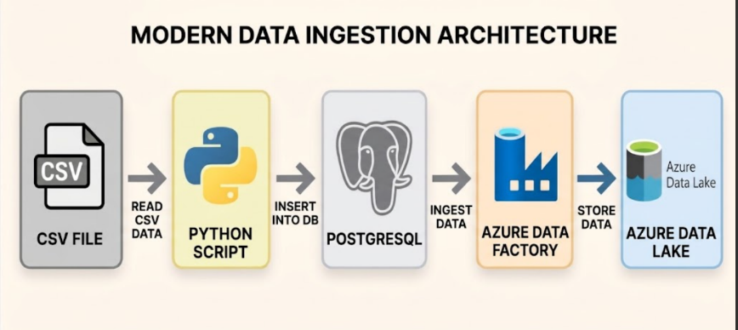
The historical dataset can be used for batch processing, baseline calculations, and
retrospective anomaly analysis.

4. Streaming Data Ingestion Using CDC
The streaming ingestion path was configured around PostgreSQL Change Data
Capture (CDC), Debezium Server, and Azure Event Hubs.
Configured architecture:
PostgreSQL → Debezium Server → Azure Event Hubs → Downstream streaming processing
The components serve the following purposes:
- PostgreSQL: Stores the source e-commerce events.
- Debezium Server: Captures database changes through PostgreSQL logical replication and converts them into change-event messages.
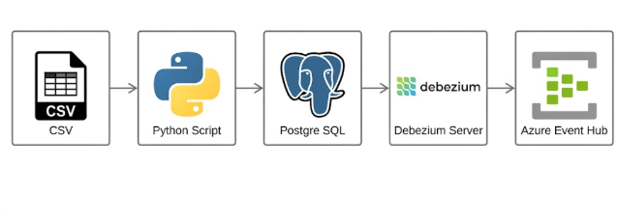
- Azure Event Hubs: Provides the event ingestion destination for downstream consumers.

- ownstream processing: Can validate events, detect anomalies, and route invalid records for further investigation.

4.2 Configuration Details
Component | Configuration
Database | ecommerce_db
Source table | streaming.ecommerce_events
PostgreSQL connector plugin | pgoutput
Replication publication | ecommerce_cdc_pub
Replication slot | ecommerce_cdc_slot
CDC database user | debezium_cdc
Snapshot mode | initial
Debezium Server version | 3.7.0.Final
Azure Event Hubs namespace | eh-ecommerce-streaming-2026
Event Hub | ecommerce-cdc-events
Offset storage | data/offsets.dat
Debezium Server was configured to run directly on Windows. Its configuration file was located at:
The initial snapshot mode is intended to capture the existing table contents when the initial snapshot is performed, while CDC captures subsequent changes through the replication mechanism.
Verification status: The PostgreSQL source table and its record count were confirmed. Debezium configuration and the Event Hubs destination were established, but complete delivery of all 9,253,804 records to Event Hubs was not conclusively verified

in the available results. Full streaming delivery should therefore be documented as pending verification.
5. Anomaly Handling Strategy
The project includes several anomaly scenarios to evaluate data quality, user behavior, traffic patterns, and event consistency.
The anomaly scenarios can be generated deliberately for testing and then detected using streaming rules, batch analysis, or both.
5.1 Cart Abandonment
Description: A user adds one or more products to a cart but does not complete a purchase within the defined session or waiting period.
Generation approach:
- Generate a user session.
- Record product views.
- Generate one or more cart events.
- End the session or allow the configured waiting period to expire without a purchase.
Detection approach:
Identify sessions containing a cart event without a subsequent qualifying purchase. The detection logic must account for session boundaries, event ordering, and the waiting period.
Processing approach: Streaming detection is possible when session state and timeout logic are implemented. Batch processing can calculate abandonment rates across historical sessions.
5.2 Bot-like Crawling Loops
Description: Automated or bot-like sessions generate unusually frequent page views or repeatedly visit the same products.
Generation approach:
- Create sessions that visit many product pages rapidly.
- Repeat the same page or navigation sequence.
- Generate a high volume of events within a short interval.
Detection approach:
Monitor event counts per time window, repeated product visits, repeated navigation sequences, and unusually short intervals between events.
Processing approach: Streaming is suitable for rapid detection and alerting. Batch analysis can identify persistent patterns over longer periods.
5.3 Seasonal Promotional Purchase Surges
Description: Purchase activity increases sharply during a simulated promotional campaign.
Generation approach:
- Define a promotional time window.
- Increase the frequency of purchasing sessions.
- Optionally increase traffic volume to simulate higher system load.
Detection approach:
Compare purchase-event counts in a short time window against an established baseline. A threshold or statistical method can identify unusually large deviations.
Processing approach: Streaming can identify a surge while it is occurring. Batch processing can calculate historical baselines and compare campaign performance across dates.
5.4 Duplicate Events
Description: The same logical event is delivered more than once, potentially causing double counting or incorrect downstream metrics.
Generation approach:
Select a percentage of generated events and resend them while retaining the original event_id.
Detection approach:
Use event_id as the primary event-level deduplication identifier, provided it is unique for each logical event. Calculate duplicate counts before cleaning and verify that the deduplication process removes repeated deliveries.
If an event_id is not present in the source schema, a stable identifier must be established before this rule can be implemented reliably.
Processing approach: Streaming deduplication can prevent repeated events from inflating live metrics. Batch deduplication can clean historical records and quantify previously observed duplicates.
5.5 Impossible Event Sequences
Description: Events violate the project's explicitly defined business rules or expected ordering.
Generation approach:
- Generate a purchase without the required preceding view or cart event.
- Generate a cart event before a required product view.
- Preserve the deliberately invalid sequence and its timestamps for testing.

Detection approach:
Evaluate events using user_id, user_session, product_id, event type, and event timestamps. Check whether required preceding events exist and whether their ordering satisfies the defined rules.
Processing approach: Streaming can detect violations when sufficient session state is available. Batch processing can audit historical sessions for the same violations.
The rules must reflect actual business requirements. For example, requiring a cart event before every purchase would incorrectly reject valid purchases if the store supports a Buy Now flow.

6. Streaming and Batch Responsibilities
Anomaly | Streaming use case | Batch use case
Cart Abandonment | Detect abandonment after the timeout or session completion | Calculate historical abandonment rates
Bot-like Crawling Loops | Detect unusually fast or repetitive activity | Analyze long-term behavioral patterns
Promotional Purchase Surges | Detect a live increase in purchases | Establish historical baselines
Duplicate Events | Deduplicate incoming events | Clean historical records
Impossible Sequences | Validate event order using session state | Audit historical event sequences
The same anomaly may be detected in both processing modes. Streaming prioritizes timely detection, while batch processing supports historical analysis, reconciliation, and aggregate reporting.
7.3 Debezium Envelope and Unsupported Operations
CDC messages can contain an operation type and an after field representing the resulting row state. The after field is normally populated for insert and update events, but it may be null for a delete event.
If the downstream pipeline is intentionally designed to accept only INSERT and UPDATE, a valid DELETE message can be rejected using the reason:
unsupported_operation
It should not be classified as malformed_json, because the message may be valid JSON and conform to the Debezium envelope structure.

The validation process should inspect the CDC operation type before requiring a non-null after object. Otherwise, a valid but unsupported delete operation could be incorrectly classified as a malformed message.
7.4 Recommended DLQ Record Contents
Each rejected message should retain enough information to support debugging and possible replay:
- Original message or payload
- Source table or source identifier
- Event identifier, when available
- CDC operation type, when available
- DLQ reason
- Validation timestamp
- Retry count, where applicable
Duplicate events and late-arriving events should not automatically be treated as malformed records. They require separate deduplication or lateness policies. Temporary infrastructure failures should normally be retried before being routed to the DLQ after the configured retry policy is exhausted.
8. Monitoring and Quality Metrics
The following metrics are suitable for monitoring the ingestion and anomaly-handling stages:
- Total source records
- Total messages received by Event Hubs
- Successful and failed event counts
- Event ingestion latency
- Duplicate-event count and rate
- Invalid-event count by DLQ reason
- Bot-like session count
- Purchase surge indicators
- Cart abandonment rate
- Impossible-sequence count
These metrics can provide evidence that the pipeline is ingesting data, applying validation rules, and isolating problematic events. Metric values should be populated from actual run results rather than estimates.
9. Current Status and Next Steps
Confirmed:
- Historical data was loaded into PostgreSQL.
- The source table contains 9,253,804 rows.
- Debezium Server configuration and Azure Event Hubs destination details are available.
- The anomaly scenarios and DLQ validation criteria have been defined.
Requires additional verification or implementation evidence:
- Whether Event Hubs received the complete expected initial dataset.
- Whether all CDC operation types are handled as intended.
- Whether the anomaly generator has produced and verified each planned scenario.
- Whether streaming anomaly detection and DLQ routing have been implemented and tested.
- Whether the proposed quality and monitoring metrics have been measured during execution.
The next stage is to validate the end-to-end ingestion flow, implement the validation and anomaly-handling rules, test each scenario with controlled inputs, and record actual results and screenshots as evidence.

10. Conclusion
The first project stage establishes the foundation for an e-commerce data engineering pipeline by loading historical data into PostgreSQL, configuring CDC-based streaming ingestion through Debezium Server and Azure Event Hubs, defining anomaly scenarios, and specifying validation rules for the DLQ.
Separating confirmed implementation results from planned functionality ensures that the documentation accurately reflects the current project status and provides a clear basis for subsequent processing, analytics, and monitoring stages.


AZURE

Azure Cost Management and Budget Alerts Setup
Project Documentation | October 2026
1. Objective
The purpose of this task was to configure cost monitoring in Microsoft Azure before starting the cloud infrastructure for the E-Commerce Clickstream Big Data Engineering project.
The main objectives were to:
- Create a monthly budget to monitor Azure spending.
- Configure email notifications for budget thresholds.
- Monitor actual and forecasted costs.
- Reduce the risk of unexpected consumption of Azure credits.
- Prepare the Azure environment for upcoming services, including Azure Data Lake Storage Gen2 and Azure Databricks.
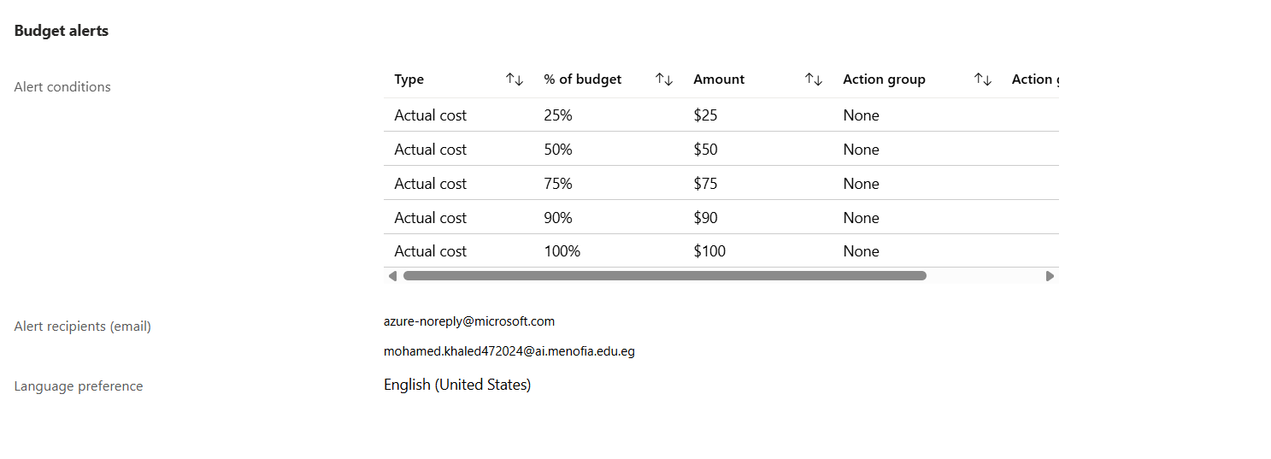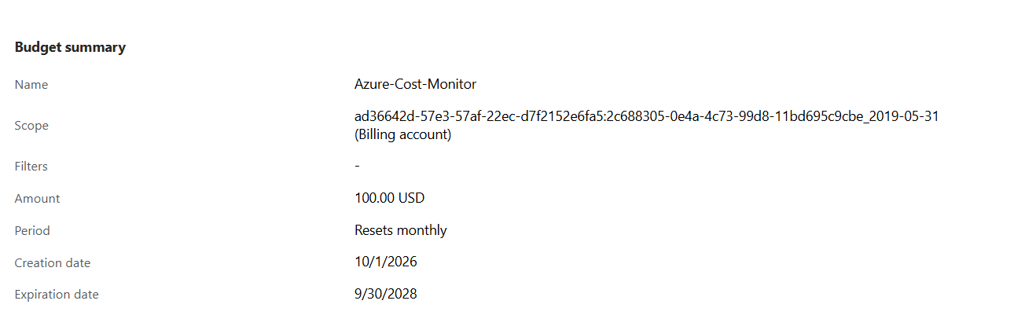
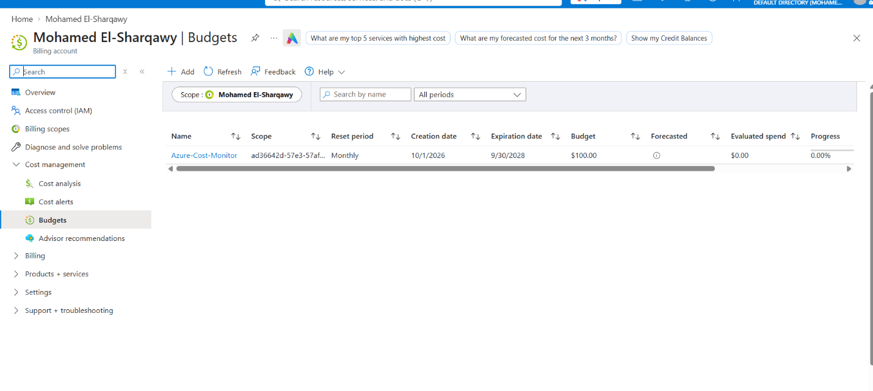

Azure Resource Group Creation
1. Objective
The objective of this task was to create an Azure Resource Group to organize and manage the cloud resources required for the E-Commerce Clickstream Big Data Engineering graduation project.
The Resource Group will serve as the logical management container for related Azure resources, such as Azure Data Lake Storage Gen2 and Azure Databricks.
2. Accessing Azure Resource Groups
We accessed the Microsoft Azure Portal at https://portal.azure.com.
From the portal, we searched for Resource groups and opened the Resource Groups service.
We then selected the option to create a new Resource Group.
3. Resource Group Configuration
We configured the Resource Group using the following settings:
Setting | Value
Resource Group Name | sic-ecommerce-clickstream
Region | Germany West Central
Subscription | The selected Azure subscription
Environment | Development
Project | SIC Graduation Project — E-Commerce Clickstream
The Resource Group name follows a consistent naming convention:
- sic-ecommerce-clickstream: Identifies the graduation project and its domain.
- dev: Indicates that the resources are intended for development and testing.
The West Europe region was selected to align with the region used in the reference tutorial, simplifying the process of following the same implementation steps.

4. Creating the Resource Group
After entering the configuration details, we reviewed the settings and submitted the creation request.
Azure created the Resource Group, making it available in the Resource Groups section of the portal.
The Resource Group provides a central place to manage related project resources, review resource configurations, apply access controls, and organize the development environment.
5. Why We Created a Resource Group
Creating a dedicated Resource Group provides several benefits:
- Resource organization: Related services can be grouped under a single project-specific container.
- Simplified management: Resources can be viewed and managed together.
- Access control: Permissions can be assigned at the Resource Group level when appropriate.
- Cost monitoring: Cost analysis can be filtered by Resource Group when the billing data and scope support it.
- Lifecycle management: Resources can be managed and eventually cleaned up as a project environment, with care taken to avoid deleting anything that must be retained.
It is important to note that a Resource Group does not itself impose a spending limit. Cost monitoring remains the responsibility of Azure Cost Management and the configured budget alerts.
6. Relationship to the Project Architecture
The Resource Group will organize the Azure resources used in the planned data engineering pipeline.
The intended architecture is:
Kaggle Clickstream Dataset → Azure Data Lake Storage Gen2 → Azure Databricks with PySpark → Delta Lake (Bronze, Silver, Gold) → Power BI
The Resource Group is the management layer that will contain the related Azure resources. The data pipeline components will be created and configured in subsequent tasks.
Azure Storage Account Setup Report
1. Objective
The objective of this phase was to create and configure an Azure Storage Account to serve as the cloud storage foundation for the E-Commerce Clickstream Lakehouse project. The storage environment will support raw data ingestion, data transformation, analytical storage, and future streaming workloads.
2. Storage Account Configuration
The Storage Account was successfully created with the following configuration:
Setting | Value
Storage Account Name | sicclickstream
Subscription | Azure for Students
Resource Group | sic-ecommerce-clickstream
Region | Germany West Central
Account Kind | StorageV2 (General-purpose v2)
Performance Tier | Standard
Redundancy | Locally Redundant Storage (LRS)
Default Blob Access Tier | Hot
Hierarchical Namespace | Enabled
Minimum TLS Version | TLS 1.2
3. Azure Data Lake Storage Gen2 Configuration
Hierarchical Namespace was enabled during Storage Account creation, making the account suitable for Azure Data Lake Storage Gen2 (ADLS Gen2).
This capability supports directory-oriented data organization and is appropriate for the planned lakehouse architecture, where data will be organized into Bronze, Silver, and Gold layers.
4. Security Configuration
The following security settings were reviewed:
- Anonymous Blob Access: Disabled to prevent anonymous access to blob data.
- Minimum TLS Version: Set to TLS 1.2.
- Hierarchical Namespace: Enabled to support ADLS Gen2.
- Secure Transfer Required: Found disabled during verification; enabling this setting was recommended.
- Default Microsoft Entra Authorization in the Azure Portal: Left disabled according to the project's current configuration preference.
The final status of the secure-transfer setting must be verified. Team access permissions will be configured separately using appropriate Azure role-based access control (RBAC).
5. Storage Redundancy and Access Tier
Locally Redundant Storage (LRS) was selected to reduce storage redundancy costs during development. LRS maintains multiple copies of data within a single physical location in the primary region.
The Hot access tier was selected because the project data is expected to be accessed frequently during ingestion, transformation, and development.
6. Planned Data Lake Structure
The Storage Account will use the Medallion Architecture to organize the project's data.
Container | Purpose
bronze | Preserve the original source dataset and store ingested clickstream events.
silver | Store cleaned, validated, and deduplicated data.
gold | Store curated analytical tables, business KPIs, and Power BI-ready datasets.
checkpoints | Store checkpoint information required by Azure Databricks Structured Streaming for recovery and processing continuity.

The streaming pipeline is planned to use a Python event generator, Azure Event Hubs, and Azure Databricks. Each streaming query will have a separate, stable checkpoint path.
Note: The four containers are planned components; their creation has not yet been confirmed.
7. Regional Deployment Consideration
The initial deployment attempt in West Europe was rejected due to the Azure for Students subscription's allowed-region policy.
Germany West Central was subsequently selected because it is included in the subscription's permitted region list and is a documented Azure Databricks supported region. Databricks availability and quota under the specific subscription must still be verified before creating its workspace.
8. Next Steps
- Create the bronze, silver, gold, and checkpoints containers.
- Verify that Secure Transfer Required is enabled.
- Configure team access permissions.
- Verify Azure Databricks availability and quota in Germany West Central.
- Connect the Storage Account to the data ingestion and processing pipelines.
Conclusion
The sicclickstream Storage Account was successfully created in Germany West Central with Standard performance, LRS redundancy, and Hierarchical Namespace enabled. It provides the planned storage foundation for the project's ADLS Gen2 lakehouse architecture and future batch and streaming processing workflows. Container creation, final security verification, and Databricks connectivity remain subsequent implementation steps.
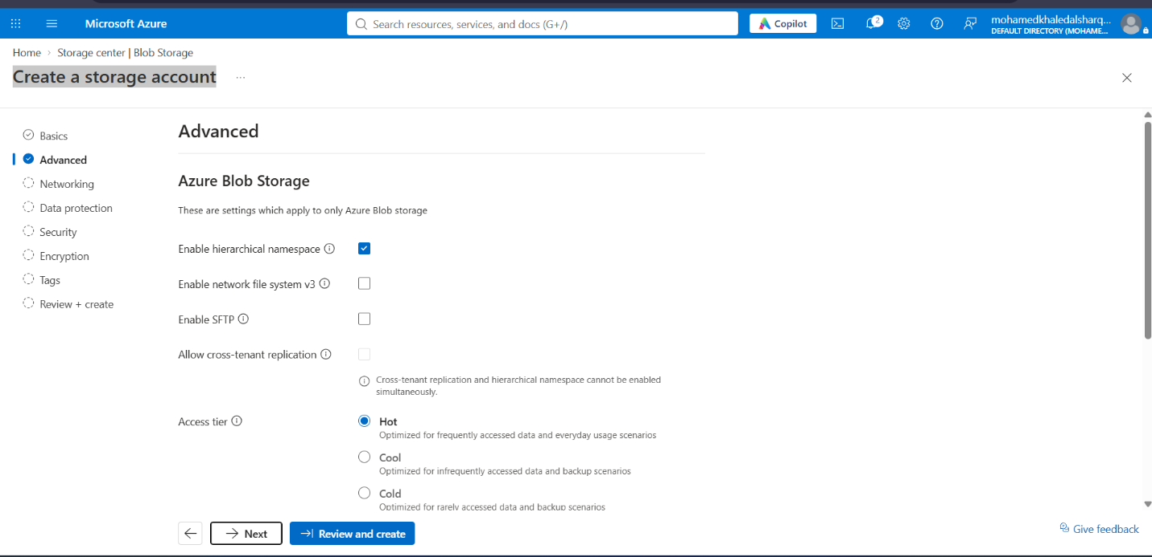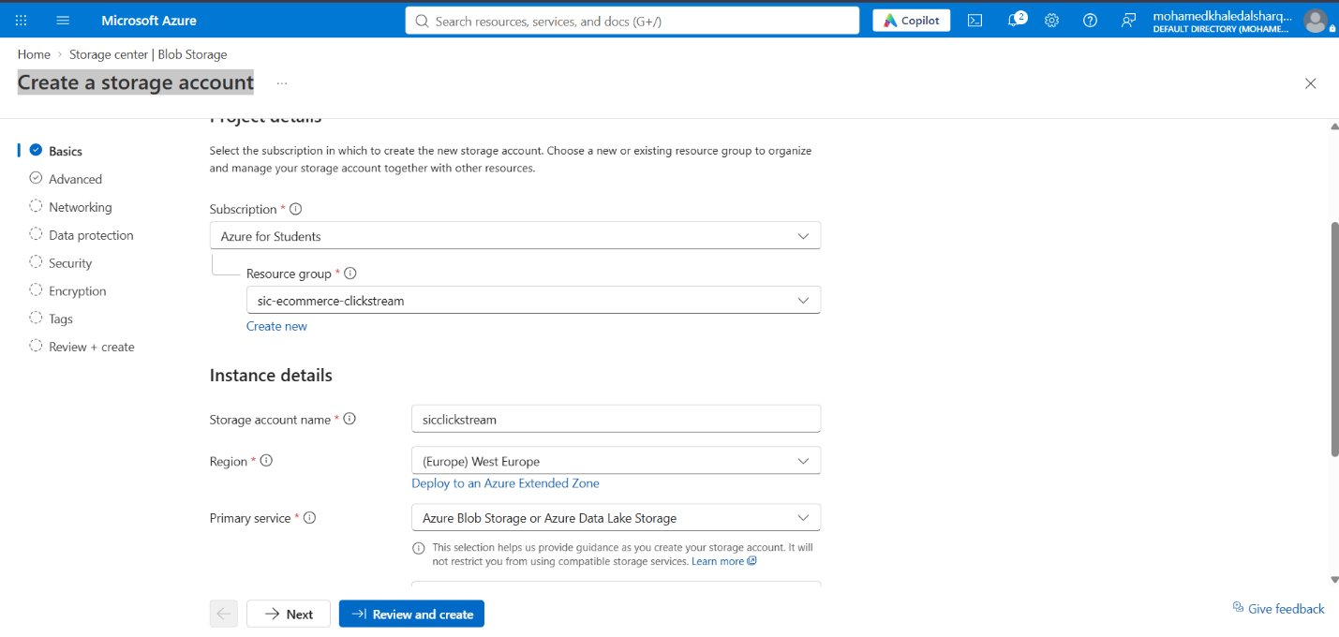

.

PostgreSQL Ingestion and Azure Event Hubs CDC Integration
Project Execution Report — E-commerce Data Engineering
Documentation date: October 25, 2026
Database: ecommerce_db
Database engine: PostgreSQL 17
Objective: Build separate Batch and Streaming ingestion pipelines, then prepare Change Data Capture (CDC) using Debezium Server to publish PostgreSQL changes to Azure Event Hubs without Kafka.

1. Project Overview
The objective of this stage is to establish PostgreSQL as a data storage component for the E-commerce Data Engineering project, ingest data from a large CSV file, and separate Batch ingestion from Streaming ingestion.
After implementing and validating both ingestion paths, the project moved toward CDC integration. The planned CDC architecture will capture database changes and publish them to Azure Event Hubs.
The main implementation stages are:
- Configure PostgreSQL inside Docker.
- Create the database schemas and tables.
- Load the first five million rows through the Batch pipeline.
- Create a separate table for Streaming simulation.
- Load the first 10,000 rows gradually.
- Create an independent Streaming checkpoint.
- Validate the results using SQL queries.
- Begin preparing PostgreSQL Logical Replication for Debezium Server and Azure Event Hubs.
Overall implementation status
Component | Status
PostgreSQL running in Docker | Implemented and tested
Database schemas and tables | Created
Batch ingestion — 5 million rows | Completed
Streaming simulation — 10,000 rows | Completed
Batch checkpoint | Existing
Streaming checkpoint | Created and verified
SQL validation | Completed
wal_level = logical | Not yet confirmed
Debezium Server configuration | Not yet implemented
Azure Event Hubs integration | Not yet implemented

2. PostgreSQL Configuration
2.1 PostgreSQL in Docker
PostgreSQL was deployed locally using Docker to isolate the database environment from the Python ingestion scripts.
Configuration | Value
Container name | ecommerce-postgres
Docker image | postgres:17
Database name | ecommerce_db
Database user | ecommerce_user
Host | localhost
Port | 5432
Persistent volume | ecommerce_pgdata
Python connects to PostgreSQL using psycopg. PostgreSQL CLI can also be used to execute SQL queries and inspect database objects.
The database password is intentionally excluded from this report.
2.2 Connecting to PostgreSQL
The following command can be used to open a PostgreSQL CLI session inside the running container:
docker exec -it ecommerce-postgres psql -U ecommerce_user -d ecommerce_db
After a successful connection, the terminal displays a prompt similar to:
ecommerce_db=#
This indicates that the PostgreSQL session is connected to the target database.
2.3 Database Version
The PostgreSQL version can be checked using:
SELECT version();
The configured Docker image is postgres:17.

3. Database Schema Organization
The database is organized into separate schemas to distinguish ingestion pipelines from monitoring metadata.
Schema | Purpose
batch | Stores data loaded by the Batch ingestion pipeline
streaming | Stores data loaded by the Streaming pipeline
monitoring | Stores ingestion checkpoints and monitoring metadata
public | Default PostgreSQL schema
This separation improves organization and prevents the Batch and Streaming pipelines from sharing the same destination tables.
The available schemas can be inspected using:
SELECT schema_name
FROM information_schema.schemata
ORDER BY schema_name;

4. Source Dataset
4.1 Source File
The original source file used for ingestion is:
D:\Samsung\Graduation Project\Data\Old Data\2019-Oct_week1_week2_combined.csv
The following specifications were established during the project:
Property | Value
Format | CSV
Dataset type | E-commerce events
Data rows | 19,749,558
Columns | 11
Approximate file size | 2.78 GiB
The dataset contains user interactions with products, including product views, cart events, and purchases.
The original file was preserved without modification. Both ingestion pipelines read from the source file and write to PostgreSQL.
4.2 Original Source Columns
The source CSV contains the following 11 columns:
event_time
event_type
product_id
category_id
category_code
brand
price
user_id
user_session
marketing_channel
platform
The Streaming destination requires only eight of these columns. The Streaming script selects the required columns by name rather than loading all 11 source columns.

5. Batch Ingestion Pipeline
5.1 Objective
The Batch pipeline loads a large portion of the source CSV into PostgreSQL using relatively large batches. It maintains a checkpoint to track ingestion progress and support recovery.
5.2 Target Table
The destination table is:
batch.ecommerce_events
The table contains the 11 original source columns. The ingestion process handles the source fields as TEXT during loading.
5.3 Batch Configuration
Setting | Value
Script | batch_ingestion.py
Script directory | D:\Samsung\Graduation Project\Data\Old Data\ingestion
Batch size | 100,000 rows
Target row count | 5,000,000 rows
Database | ecommerce_db
Target table | batch.ecommerce_events
Checkpoint schema | monitoring
The script uses Python's psycopg library and PostgreSQL COPY functionality to load data efficiently.
Each batch is processed in a separate transaction.
5.4 Batch Checkpoint
The Batch pipeline uses the following checkpoint table:
monitoring.ingestion_checkpoints
The table contains these columns:
Column | Data type | Purpose
source_path | TEXT PRIMARY KEY | Identifies the source file
file_size_bytes | BIGINT | Stores the file size
file_mtime_ns | BIGINT | Stores the file modification timestamp
last_row_number | BIGINT | Tracks the last processed data row
updated_at | TIMESTAMPTZ | Records the checkpoint update time
Before resuming ingestion, the script can compare the current file size and modification timestamp with the saved values to detect changes to the source file.
5.5 Batch Execution Results
The following query was used to verify the loaded row count:
SELECT COUNT(*)
FROM batch.ecommerce_events;
The result was:
count
-------
5000000
(1 row)
Result: 5,000,000 rows were successfully loaded into the Batch destination table.

6. Streaming Simulation Pipeline
6.1 Objective
The Streaming Simulation pipeline demonstrates gradual event arrival rather than loading all selected rows in one operation.
At this stage, the pipeline reads records directly from the CSV and inserts them into PostgreSQL in small batches with a time delay between batches.
Kafka and Azure Event Hubs are not used in this simulation.
6.2 Streaming Destination Table
The target table is:
streaming.ecommerce_events
The table was created using the following SQL statement:
CREATE TABLE IF NOT EXISTS streaming.ecommerce_events (
event_time TEXT,
event_type TEXT,
user_id TEXT,
product_id TEXT,
price TEXT,
marketing_channel TEXT,
platform TEXT,
user_session TEXT
);
The IF NOT EXISTS clause prevents PostgreSQL from recreating the table if it already exists.
The actual table columns were verified using:
SELECT column_name
FROM information_schema.columns
WHERE table_schema = 'streaming'
AND table_name = 'ecommerce_events'
ORDER BY ordinal_position;
The query confirmed the following eight columns in the required order:
- event_time
- event_type
- user_id
- product_id
- price
- marketing_channel
- platform
- user_session
6.3 Streaming Checkpoint Table
A separate checkpoint table was created for the Streaming pipeline:
CREATE TABLE IF NOT EXISTS monitoring.streaming_checkpoints (
source_path TEXT PRIMARY KEY,
file_size_bytes BIGINT NOT NULL,
file_mtime_ns BIGINT NOT NULL,
last_row_number BIGINT NOT NULL DEFAULT 0,
updated_at TIMESTAMPTZ NOT NULL DEFAULT NOW()
);
The purpose of this table is to track Streaming progress independently of the Batch checkpoint.
6.4 Streaming Script Configuration
The following script was created:
D:\Samsung\Graduation Project\Data\Old Data\ingestion\streaming_ingestion.py
The initial test used the following configuration:
Setting | Value
Source file | 2019-Oct_week1_week2_combined.csv
Destination | streaming.ecommerce_events
Target rows | 10,000
Batch size | 100 rows
Delay | 1 second between successful batches
Checkpoint | monitoring.streaming_checkpoints
Python database driver | psycopg
6.5 Streaming Execution Logic
The script performs the following operations:
- Checks that the source CSV exists.
- Reads the CSV header.
- Validates that the required source columns are present.
- Selects the eight required columns by name.
- Skips previously processed data rows when resuming from a checkpoint.
- Inserts 100 rows per batch.
- Updates the checkpoint in the same transaction as the data insertion.
- Waits one second between successful batches.
- Prints progress during execution.
- Reports the final target table row count and checkpoint value.
The script uses csv.DictReader, which retrieves values by column name. This is important because the original CSV column order differs from the Streaming table's column order.
6.6 Running the Streaming Script
The script can be launched using PowerShell:
cd "D:\Samsung\Graduation Project\Data\Old Data\ingestion"
python streaming_ingestion.py
The script requests the PostgreSQL password at runtime.
6.7 Checkpoint and Recovery Behavior
The script stops if the target table contains rows but no matching checkpoint exists. This prevents accidental duplicate loading when the initial state is unknown.
It also checks the source file's size and modification timestamp before resuming.

7. Streaming Execution Results
The script completed successfully and printed the following final output:
Progress: 9,700/10,000 rows loaded
Progress: 9,800/10,000 rows loaded
Progress: 9,900/10,000 rows loaded
Progress: 10,000/10,000 rows loaded

Streaming simulation finished.
Rows in target table: 10,000
Last source row checkpointed: 10,000
The output confirms that:
- The simulation completed successfully.
- The target table contains 10,000 rows.
- The checkpoint reached row 10,000.
- The script inserted records incrementally in batches of 100.
The configured one-second delay between batches accounts for approximately 100 seconds of waiting time, in addition to CSV reading and database insertion time.
Technical clarification: This implementation is a Streaming Simulation or Event Replay pipeline. It is not yet CDC and does not use Azure Event Hubs. It reads CSV records and writes directly to PostgreSQL.

8. SQL Validation Results
After the Streaming script completed, several SQL queries were executed to validate the data.
8.1 Total Row Count
-- Total number of rows
SELECT COUNT(*)
FROM streaming.ecommerce_events;
Result:
count
-------
10000
(1 row)
The Streaming table contains 10,000 rows.

8.2 Event Type Distribution
-- Event type distribution
SELECT event_type, COUNT(*) AS events_count
FROM streaming.ecommerce_events
GROUP BY event_type
ORDER BY events_count DESC;
Results:
Event type | Event count | Percentage
view | 9,785 | 97.85%
purchase | 118 | 1.18%
cart | 97 | 0.97%
Total | 10,000 | 100%
This distribution describes the first 10,000 rows loaded from the source file. It should not be interpreted as the distribution of the entire dataset.
8.3 Event Distribution by Platform
-- Event distribution by platform
SELECT platform, COUNT(*) AS events_count
FROM streaming.ecommerce_events
GROUP BY platform
ORDER BY events_count DESC;
Results:
Platform | Event count | Percentage
Web | 5,001 | 50.01%
Mobile App | 4,999 | 49.99%
Total | 10,000 | 100%
The two platforms account for all 10,000 loaded records.
8.4 Streaming Checkpoint Status
-- Checkpoint status
SELECT source_path, last_row_number, updated_at
FROM monitoring.streaming_checkpoints;
The verified result was:
Property | Value
Source path | D:\Samsung\Graduation Project\Data\Old Data\2019-Oct_week1_week2_combined.csv
Last processed row | 10,000
Last update | 2026-10-25 13:47:19.495548+00
The timestamp is stored as TIMESTAMPTZ. The +00 suffix indicates that the displayed timestamp is in UTC.

9. Planned Azure Event Hubs Integration
9.1 Objective
The next stage is to publish PostgreSQL changes to Azure Event Hubs using CDC, without Kafka and without rereading the CSV to produce new events.
The proposed technology is Debezium Server.
9.2 Target Architecture
PostgreSQL
|
| WAL / Logical Replication
v
Debezium Server
|
| Azure Event Hubs Sink

Azure Event Hubs
In this architecture:
- PostgreSQL is the source database.
- The Write-Ahead Log (WAL) records database changes.
- Debezium captures the changes through CDC.
- Debezium Server publishes the captured events to Azure Event Hubs.
- Azure Event Hubs makes the events available to downstream streaming consumers.
This differs from the existing simulation because the source of events will be database changes rather than a replay of CSV records.
9.3 Handling Existing Rows
The streaming.ecommerce_events table already contains 10,000 rows from the initial CSV ingestion.
If these existing records must also be published to Event Hubs, the Debezium snapshot configuration must determine whether to emit an initial snapshot.
After CDC starts, the goal is to capture new changes, such as new rows inserted into the target table.
The initial snapshot policy must be selected deliberately to avoid unintentionally replaying existing records.
9.4 CDC Configuration Requirements
Before running Debezium Server, the following configuration work is required:
- Enable wal_level = logical.
- Configure suitable values for max_replication_slots and max_wal_senders.
- Create a PostgreSQL publication for the target table.
- Configure the required replication permissions.
- Create an Azure Event Hubs Namespace and Event Hub.
- Configure secure connection credentials.
- Configure Debezium Server's PostgreSQL source and Azure Event Hubs sink.
- Select the initial snapshot policy.
- Test the end-to-end flow by creating a database change and confirming that the corresponding event reaches Event Hubs.

10. Current PostgreSQL WAL Configuration
The following query was executed:
SHOW wal_level;
The verified output was:
wal_level
-----------
replica
(1 row)
The current confirmed WAL level is replica, which is not the required setting for the planned logical CDC setup.
10.1 Proposed Configuration Change
The following command was proposed but its execution has not yet been confirmed:
ALTER SYSTEM SET wal_level = 'logical';
PostgreSQL must be restarted for the new WAL level to take effect.
The proposed Docker restart command is:
docker restart ecommerce-postgres
After the container restarts, verify the configuration again:
SHOW wal_level;
The required result is:
logical
Current status: The latest confirmed value remains replica. Logical replication must not be considered enabled until the configuration change, restart, and verification are completed successfully.

11. Security and Reliability Considerations
The following considerations should be addressed before deploying the CDC integration:
- Do not hardcode passwords or Azure credentials in source code or Git repositories.
- Use environment variables or a secure secrets-management solution.
- Grant Debezium only the permissions it requires.
- Monitor replication slots and WAL disk consumption.
- Define recovery and retention policies.
- Account for possible duplicate event delivery and design downstream consumers to handle repeated events safely.
- Ensure CDC progress can be recovered after interruptions.
- Test resource consumption before processing the entire dataset.
- Keep the Batch and Streaming pipelines logically separate.

12. Final Summary
Two ingestion stages have been implemented and validated in PostgreSQL.
Batch Pipeline
- Source: Original CSV file.
- Destination: batch.ecommerce_events.
- Loaded rows: 9M record.
- Checkpoint: Existing Batch checkpoint mechanism.
Streaming Simulation
- Source: Original CSV file.
- Destination: streaming.ecommerce_events.
- Loaded rows: 10,000.
- Batch size: 100 rows.
- Delay: One second between batches.
- Checkpoint: monitoring.streaming_checkpoints, verified at row 10,000.
- Validation: Row count, event type distribution, platform distribution, and checkpoint status were verified successfully.
Next Stage
The next stage is to finish PostgreSQL Logical Replication configuration, then configure Debezium Server and Azure Event Hubs. The integration must be tested with both the selected initial snapshot behavior and new database changes.
Conclusion: The PostgreSQL database and the Batch and Streaming ingestion pipelines have been implemented and tested. The Debezium Server–Azure Event Hubs CDC integration remains planned work and has not yet been executed or validated.

